

Higher Institute of Engineering & Technology, El-Beheira

Computer Engineering Department

Third assignment in numerical analysis

**The numerical solution of a system of non-linear equations using Newton’s Method.)**

Under supervision of Dr.Mahmoud Gamal

|  |  |
| --- | --- |
| Team | ID |
| Mohamed Yosry El-Zarka | 19100 |
| Youssef Mohamed El-Sheheimy | 19124 |
| Omar Abd Al-Halim Khalil | 19138 |

**Source code in python: -**

1 import math

2 from sympy import * #for differentiation & mathematical functions

3 import numpy as np #matrix operations

4

5 pi=3.141592653589793

6 e=2.718281828459045

7

8 print('Project for "Numerical analysis". under the supervision of Dr. Mahmoud Gamal')

9 print('by:')

10 print('\t\tMohamed Yosry ElZarka 19100')

11 print('\t\tYoussef Mohamed Elsheheimy 19124')

12 print('\t\tOmar Abd Al-Halim Khalil 19138\n')

13

14 print("This is a program to calculate the numerical solution of a system of non-linear equations using (Newton's method).\n")

15

16 print("""

17 you can use parentheses () in addition to the following mathematical operators:

18 (+ Add), (- Subtract), (* Multiply), (/ Divide), (% Modulus), (// Floor division), (** Exponent)

19 you can also use the following constants:

20 \t pi=3.141592653589793

21 \t e=2.718281828459045

22 note: Trigonometric functions sin(x), asin(x), cos(x), acos(x), tan(x), atan(x) 'equivalent of tan-1(x)' use radian values.

23       log(x,y)= log(x) / log(y) ,,, ln(x)

24 """)

25

26 def check_equalization(recent_x,previous_x):

27     for i in range (0, len(recent_x)):

28         if recent_x[i] != previous_x[i]:

29             return False

30     return True

31

32 decimal_point_precision=4

33

34 while True:

35     n=int( input('Enter the number of equations: ') )

36     equations, equations_values, jacobian_matrix, jacobian_values= [] , [0]*n , [] , []

37

38     for i in range(0,n):

39         equations.append( str(input("Enter the equation #{}:    0 = ".format(i+1))) )

40         jacobian_matrix.append([])

41         jacobian_values.append([0]*n)

42     last_x , current_x= [] , []

43     for i in range(0,n):

44         last_x.append( float(input("Enter the initial x{} = ".format(i+1))) )

45

46     for i in range(0,n): #partial differntiaion matrix

47         for j in range(0,n):

48             jacobian_matrix[i].append(  diff( equations[i] , 'x'+str(j+1) ) )

49

50     print("\njacobian matrix=",jacobian_matrix)

51

52     print("\n        ",end="")

53     for i in range(0,n):

54         print("x{}          ".format(i+1),end="")

55     print("")

56     print("i=0",end="")

57     for i in range(0,n):

58         last_x[i]=round( last_x[i] , decimal_point_precision )

59         print(" | %.4f | "%last_x[i],end="")

60     print("")

61

62     dictionary_of_last_x={}

63

64     for iterations in range(1,500): #maximum number of iterations is 500

65         for i in range(0,n): #updating the values of matrices

66             dictionary_of_last_x['x'+str(i+1)]=last_x[i]

67         for i in range(0,n):

68             equations_values[i]=round( eval(equations[i],dictionary_of_last_x) , decimal_point_precision)

69         for i in range(0,n):

70             for j in range(0,n):

71                 jacobian_values[i][j]=round( eval(str(jacobian_matrix[i][j]),dictionary_of_last_x) , decimal_point_precision )

72

73         A = np.array(last_x) #matrix declarations

74         B = np.array(jacobian_values)

75         C = np.array(equations_values)

76

77         current_x=np.subtract(A, np.dot( np.linalg.inv(B)  , C ) ) #matrix operations

78

79         print("i={}".format(iterations),end="")

80         for i in range(0,n):

81             current_x[i]=round( current_x[i] , decimal_point_precision )

82             print(" | %.4f | "%current_x[i],end="")

83         print("")

84         if check_equalization(current_x,last_x):

85             break

86         last_x=current_x

87

88     print("\nAfter",iterations,"iterations, The solution is at")

89     for i in range(0,n):

90         print("\t\tx{} =".format(i+1),last_x[i])

91     print("\n____________________________________________")

92     print("Try another system of non-linear equations.")

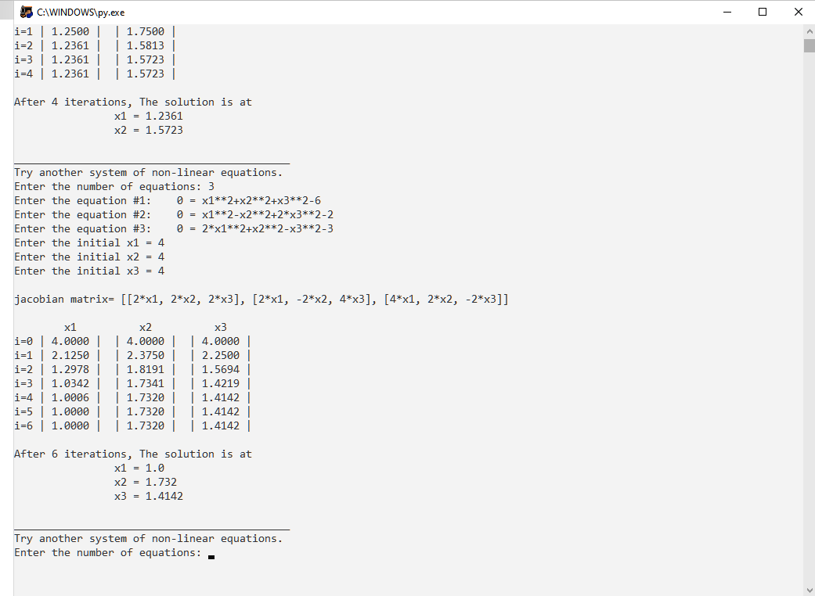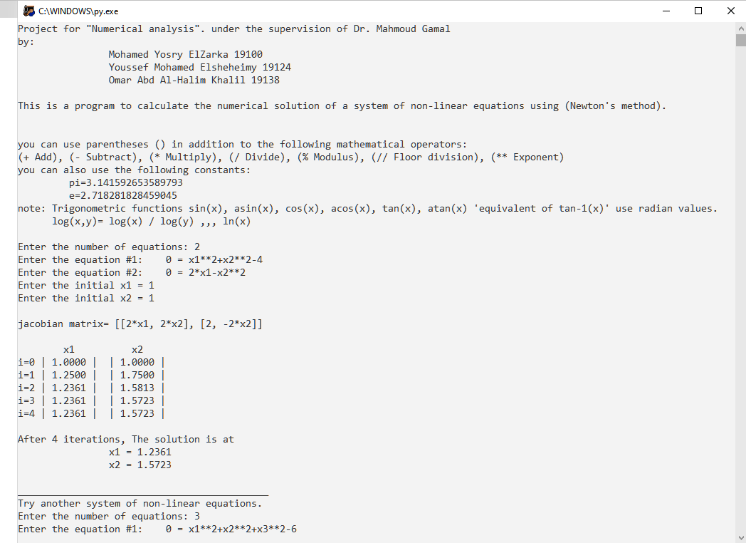**The program**